**Salary and compensation policy**

Step – 1 - Salary and compensation calculations starts at month start

Step – 2 - We has to collect few details from HR department in an excel format.

* Existing Employees Detail.

1. Employee Name
2. Total working days in a month
3. Total weekends (for HR and admin working)
4. Total Payable days
5. Payable days of individual employees in a month
6. Loss of pay (Absent count)
7. Late comings of individual employees
8. Employees leaving during the month.

* New employees added during the month

1. Employee ID
2. Employee Name
3. Employee Designation
4. Monthly Salary CTC
5. Probation period
6. Retention

**Step – 3) How to make salary sheet from attendance sheet ?**

* Attendance sheet has to be arrange according to salary sheet.
* New employee names will be entered in the salary sheet from the attendance sheet at the bottom.
* The names of the last month relived employees will be removed from the salary sheet.
* Enter the details from the attendance sheet in the salary sheet.

1. Present days
2. Absent days
3. Late comings
4. Other attendance regarding adjustment.

**Step – 4) How do we calculate the leaves in the salary sheet ?**

* Leave balance C/F from the last month's salary sheet will be entered in this month's leave balance column.
* Will one (1) leave has to be added in the leave earned column.

**Note:-**

1. Employees those who are in training /probation period and serving notice period are not eligible for paid leave.
2. If anyone has taken 5 or more leave in a month for any reason he will not be eligible for One (1) paid leave.

* Attendance Bonus 0.5 day will add the eligible employees in the 0.5 Day Attendance Bonus column.

**Note:-** Attendance bonus will be given to those employees who do not have any leave and 3 late coming mark this month.

* 3 Late Coming We will deduct 0.5 day salary of the employee.

**Step – 5) How to calculate salary of employee in salary sheet ?**

* After the leave calculation is done in the salary sheet, the Absent Leave will be entered in the Days to Be Deducted column.
* Working day manually will be entered in the (Days to Be Deducted in Amt.) column.
* Target and achievements for BD only calculation, Petrol conveyance and other adjustment amount will be entered in the (Other allowances) column.
* Late coming, advance salary and other adjustment amount will be entered in (Other Deduction) column.

**Note:-**

1. In the salary sheet, EPF / ESIC, TDS and PT calculations are done by Accountant Nishikant sir. We do not have to do anything in it.
2. Gross salary and net salary calculation is automatic. We do not have to do anything in it.

**Step – 6) How to calculate Retention Bonus in salary sheet ?**

* Retention Bonus Details come from HR Department for a new employees or at the time of PE retention bonus sheet.
* Retention Bonus manually will be entered in the (Retention Bonus) column. From Retention Bonus Sheet to Salary Sheet.
* We have to enter this month's retention bonus and total bonus.

Ex. 8333 / 100008 for 12 months.

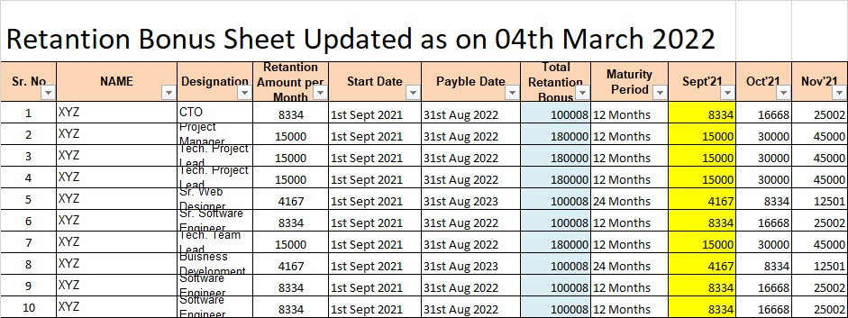

**Step – 7) Prepare Salary sheets supporting sheets.**

1. Will get salary final EPF/ESIC and TDS calculated sheet from Accountant Nishikant sir.
2. Will prepare salary notes sheet from salary sheet.
3. Employees attendance bonus, (Target and achievements for BD only calculation), Petrol conveyance and other adjustment amount and details will be entered in the sheet.
4. Late coming, advance salary and other adjustment amount will be entered in the sheet.
5. Retention Bonus details manually will be entered in the Sheet.

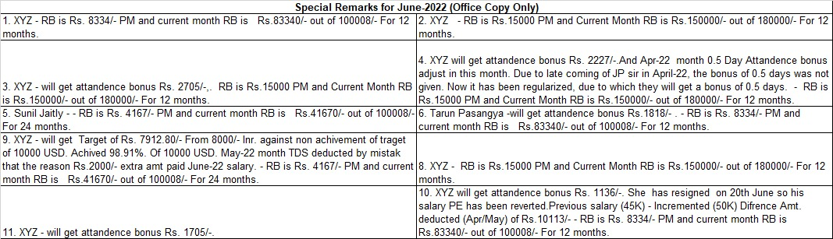

1. Will prepare salary comparison sheet from salary sheet.
2. Employees last month and current month payable salary will be entered in the Sheet.
3. If there is more or less than 5% in the last month and current month salary, write the reason for it in the Remark column.
4. The employees whose salary will be received by check will be marked as CHQ in the BP/CHQ column and those whose salary is in the bank, they will mark BP in the BP/CHQ column.

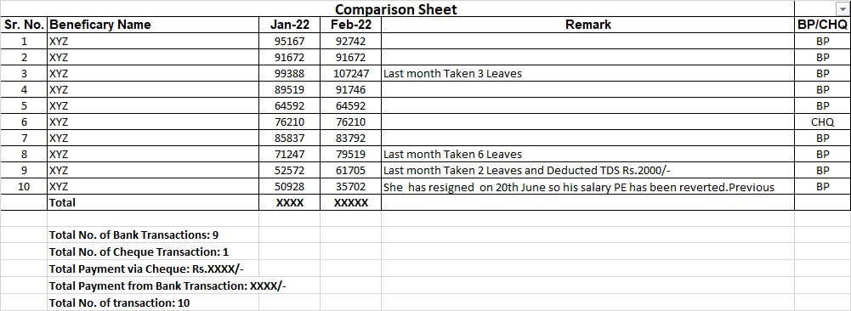

1. Will prepare Bulk payment transfer sheet from salary sheet.
2. Create bulk payment sheet to transfer salary from bank.
3. Bulk payment sheet will be named as Payment Bulk and current date.
4. In the payment type column, if Standard charted bank account, it will write (BT) and if it is another bank account, it will write ACH
5. Write the date of the day on which you will credit the salary in the payment column.

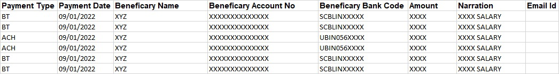

1. Will prepare cheque payment sheet from salary sheet.
2. Salary checks will be made for those who have employee been relieved last month.

|  |  |  |  |
| --- | --- | --- | --- |
| **Cheque Sheet** | | | |
| **Sr. No** | **Name** | **Salary Amt.** | **Cheque** |
| 1 | XYZ | XXXX | Cheque |
| 2 | XYZ | XXXX | Cheque |
| 3 | XYZ | XXXX | Cheque |
| 4 | XYZ | XXXX | Cheque |
| 5 | XYZ | XXXX | Cheque |
|  |  |  |  |
|  | **Total** | **XXXXX** |  |
|  |  |  |  |
|  |  |  |  |
|  |  |  |  |

1. Will prepare salary slips from salary sheet.
2. Leaves, Earning, allowances and deductions will be entered from the salary sheet in the salary slip.
3. The designation, employee code, CTC, retention bounce and bank account number from the HR department will be entered in the salary slip.

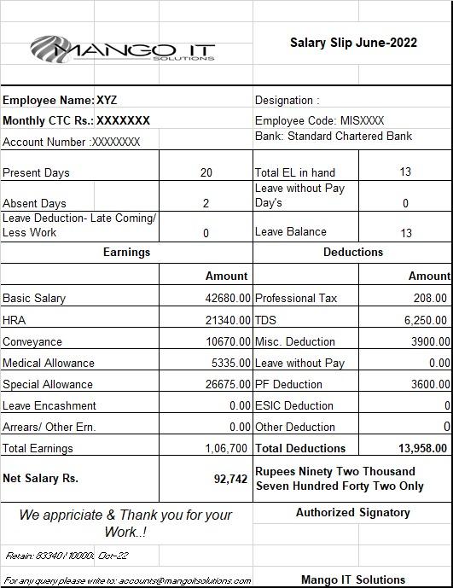

**Step – 8) Take final salary sheet and all payroll sheet print out and submitted to Vivek sir.**

**Step – 9) Sand final salary sheet by mail to accountant Nishikant sir for EPF/ESIC and TDS calculation.**

**Step – 10) Sand final Salary sheet and all pay roll sheet by mail to Vivek sir for Salary transfer prosess.**

**Step – 11) Sand Final EPF/ESIC sheet by mail to EPF/ESIC consultant Vijay Vijayvargiya sir for Challan.**

**Step – 12) Receive EPF/ESIC challan from EPF/ESIC consultant Vijay Vijayvargiya sir and paid challan through yes bank.**

**Step – 13) Take final salary sheet and all payroll sheet print out and file.**